**CHAPTER 1**

**INTRODUCTION**

**1.1 GENERAL INTRODUCTION**

The digital age has introduced a vast array of books across various platforms, making it difficult for readers to discover titles that align with their preferences. Traditional methods of book discovery, such as bestseller lists and author-following, often fail to provide personalized recommendations. As a solution, book recommendation systems have become essential tools that suggest books based on user interactions and preferences.

A **book recommendation system** is a tool designed to suggest books to users based on various data points, including past ratings, book genres, and other metadata. These systems are essential in guiding users toward books they are likely to enjoy, saving time and enhancing the user experience. With millions of books available online, users often feel overwhelmed by the choices available. A personalized recommendation engine simplifies this process, suggesting books based on the user’s reading habits and preferences.

The primary goal of this project is to build a **book recommendation system** using data science techniques, focusing on both **collaborative filtering** and **content-based filtering** approaches. By leveraging data from **Goodreads**—which includes user ratings, book titles, and other relevant metadata—this system will generate personalized recommendations for users based on their interaction history and book preferences. The key advantage of this system lies in its ability to provide users with relevant suggestions even without the need for sophisticated machine learning algorithms.

The development of this recommendation system will provide users with more relevant book suggestions, improving their experience on digital reading platforms. Additionally, it will help users discover books outside the mainstream, offering them a wider variety of genres, authors, and topics based on their interests.

This recommendation system will be especially beneficial for platforms like Goodreads, Amazon, and online libraries that aim to enhance user engagement by recommending books that match user preferences. By creating personalized reading lists, the system will improve user retention and overall satisfaction

**1.2 PROBLEM DEFINITION**

The problem of information overload in the digital book space has become increasingly apparent. With millions of books available on platforms such as Goodreads, Amazon, and other online bookstores, readers often find it challenging to select books that suit their preferences. While users may browse through search results or look at bestseller lists, these methods are insufficient for providing truly personalized book recommendations. Without a recommendation system, readers are left to navigate an overwhelming number of titles, often struggling to find books that meet their specific interests.

One major issue is the **cold start problem**. This problem arises when the system lacks enough data to make recommendations, particularly for new users or books with few ratings. When a new user joins a platform and has not yet rated books, the system cannot accurately predict their preferences based on past behaviour. Similarly, newly added books without sufficient user ratings are hard to recommend. This leads to poor recommendations for new users or newly added books, hindering the overall effectiveness of the system.

Another problem is **data sparsity**, which occurs when users interact with only a small subset of available books. In collaborative filtering, for instance, the system relies on the assumption that users who rated similar books in the past will continue to have similar preferences in the future. However, when users have rated only a few books, the system may struggle to find meaningful relationships between users, making recommendations less accurate.

Additionally, **scalability** is an important consideration. As the number of books and users grows, the data involved in generating recommendations becomes increasingly complex. The computational resources required to process large datasets can overwhelm traditional recommendation algorithms, leading to slower performance and longer processing times. A scalable system is essential to handle large volumes of data efficiently while maintaining the quality of recommendations.

This project seeks to address these challenges by using collaborative filtering and content-based filtering methods. These techniques will be designed to handle data sparsity and cold start problems, providing users with relevant recommendations even when data is limited. Furthermore, the system will be optimized to scale with the increasing number of users and books, ensuring that the recommendations remain accurate and timely.

**1.3 PROJECT OVERVIEW**

The goal of this project is to develop a book recommendation system based on **data science techniques,** specifically using collaborative filtering and content-based filtering methods. The system will be built using real-world data from Goodreads, which contains detailed information about books, including titles, authors, genres, and user ratings. This data will serve as the foundation for generating personalized book recommendations.

1. **Collaborative Filtering:** Collaborative filtering is a technique used to recommend items based on the preferences of similar users. In this project, collaborative filtering will be employed to recommend books to users by analyzing the ratings and behaviours of other users who have similar tastes. The system will create a user-item matrix where rows represent users, and columns represent books. The matrix will be sparse, meaning that not all users will have rated all the books. The system will use this matrix to identify similarities between users and recommend books liked by similar users.
2. **Content-Based Filtering:** Content-based filtering works by recommending items that are similar to those a user has already interacted with, based on item attributes. In the case of books, these attributes may include genre, author, title, and other metadata. This technique will allow the system to recommend books with similar characteristics to those a user has previously rated highly, even if other users have not rated the same books.

The hybrid recommendation system will combine these two methods to generate recommendations that are both personalized and diverse. By merging collaborative filtering (which looks at user behaviour) and content-based filtering (which considers book metadata), the system will address the limitations of each approach and offer more accurate and relevant recommendations.

The recommendation engine will be implemented in **Python**, utilizing libraries such as **pandas**, **numpy**, and **scipy** for data manipulation and calculation. The system will use **cosine similarity** to measure the similarity between users (for collaborative filtering) and between books (for content-based filtering). The system will be designed to efficiently handle large datasets, ensuring scalability as the number of books and users increases.

**1.4 ADVANTAGES OF BOOK RECOMMENDATION SYSTEMS**

A well-designed book recommendation system provides numerous advantages for users, platforms, and businesses alike. Here are the key benefits:

**1. Personalization:** The primary advantage of a book recommendation system is its ability to offer personalized book suggestions based on a user's unique preferences. By analyzing user ratings and past interactions, the system can recommend books that match individual tastes, enhancing the user experience.

**2. Discoverability of Books:** With millions of books available online, many titles can easily be overlooked. A recommendation system helps surface hidden gems by suggesting books based on specific user preferences. This increases the likelihood of readers discovering new books that might otherwise go unnoticed.

**3. Efficiency and Time-Saving:** A recommendation system reduces the time users spend browsing for books. Instead of scrolling through endless lists, users can receive curated suggestions, making it easier and faster to find books they are likely to enjoy.

**4. Enhanced User Engagement:** By offering relevant book suggestions, recommendation systems encourage users to engage more with the platform. They are more likely to rate books, write reviews, and interact with the system, leading to a more active and satisfied user base.

**5. Improved Sales and Revenue**: For businesses, implementing a recommendation system can increase sales by guiding users toward books they are more likely to purchase. The system enhances the discovery of both popular and niche books, driving more transactions and generating higher revenue.

**6. Support for Niche Content:** A recommendation system can also help promote books that are outside the mainstream, benefiting authors and publishers with niche books. By recommending books based on content attributes such as genre or author, the system can connect readers with titles they may not have otherwise found.

In conclusion, book recommendation systems offer valuable benefits for users and businesses by personalizing the reading experience, improving book discoverability, and enhancing user engagement. The system’s ability to recommend books efficiently based on user preferences not only saves time but also contributes to the overall success of book platforms and the broader book industry.

**CHAPTER-2**

**LITERATURE SURVEY**

**2.1 BACKGROUND**

The Book Recommendation System project arises from the growing demand for personalized book suggestions in an era dominated by vast digital libraries and online reading platforms. Historically, readers relied on manual searches, bestseller lists, or personal recommendations to discover books. However, these traditional methods often fail to address individual preferences, leaving users overwhelmed with options and dissatisfied with their reading experiences. The Book Recommendation System aims to bridge this gap by leveraging data-driven methodologies to offer customized recommendations tailored to each user's unique tastes.

The motivation for developing this system stems from the challenges faced by readers and platforms alike. Readers struggle to identify books aligned with their interests amidst the plethora of options, while platforms face the challenge of retaining users by delivering meaningful suggestions. By utilizing collaborative filtering and content-based filtering, this system seeks to enhance user satisfaction by making book discovery effortless and engaging.

At the heart of the project lies the integration of Goodreads data, which includes user ratings, book titles, and other metadata. This rich dataset forms the foundation for analyzing user preferences and book attributes. The project emphasizes the importance of data preprocessing, which involves cleaning and organizing raw data to ensure accuracy and reliability in recommendations.

Furthermore, the system prioritizes scalability to accommodate the growing number of users and books on online platforms. The project's architecture is designed to handle large datasets efficiently, ensuring that the system remains responsive and effective even as data volume increases. Additionally, the system incorporates robust mechanisms to address the cold start problem—a common issue in recommendation systems where insufficient data makes it challenging to generate recommendations for new users or books.

The development of the Book Recommendation System is a collaborative effort, drawing insights from various fields, including data science, user experience design, and software engineering. The project has been carefully planned and executed to align with the expectations of users and the broader goals of book platforms. Through this project, we aim to revolutionize the way readers discover books, making personalized recommendations a standard feature in the digital reading ecosystem.

**2.2 LITERATURE REVIEW**

A thorough review of existing systems and techniques was conducted to inform the development of the Book Recommendation System. The literature highlights the widespread adoption of recommendation algorithms across various domains, such as e-commerce, streaming services, and online learning platforms.

By studying these systems, we identified methodologies and features that could be adapted to the domain of book recommendations.

1. **Collaborative Filtering**

Collaborative filtering is widely regarded as a cornerstone of recommendation systems. It operates on the premise that users with similar preferences will have overlapping interests. Studies have shown that collaborative filtering excels in generating personalized recommendations by analyzing user-item interactions. However, it is prone to challenges such as the cold start problem and data sparsity, which were key considerations in designing this project.

**ii. Content-Based Filtering**

Content-based filtering focuses on recommending items similar to those a user has interacted with in the past. This approach leverages item metadata, such as genre, author, and description, to establish relationships between books. The literature suggests that content-based filtering is particularly effective when paired with collaborative filtering, as it mitigates the limitations of user-based recommendations by considering item attributes.

**iii. Hybrid Approaches**

Many modern systems combine collaborative and content-based filtering to deliver more accurate and diverse recommendations. This hybrid approach has been widely adopted in platforms such as Amazon and Netflix. Inspired by these systems, the Book Recommendation System integrates both methodologies to achieve a balance between personalization and scalability.

**iv. Goodreads Data Utilization**

Research into Goodreads as a data source highlights its potential for powering recommendation systems. With millions of user ratings and reviews, Goodreads provides a robust dataset for analyzing reading trends and preferences. The literature emphasizes the importance of preprocessing and cleaning Goodreads data to address issues such as duplicate entries, missing values, and inconsistencies.

The insights gained from these studies have been instrumental in shaping the design and functionality of the Book Recommendation System. By building on established methodologies and addressing their limitations, this project aims to deliver a state-of-the-art solution for personalized book recommendations.

**2.3 FEASIBILITY STUDY**

A feasibility study was conducted to evaluate the practicality and viability of the Book Recommendation System. The study focused on three primary aspects: technical feasibility, economic feasibility, and operational feasibility.

**TECHNICAL FEASIBILITY**

The project is technically feasible due to the availability of mature tools and technologies required for its implementation. Libraries like pandas, scikit-learn, and NumPy provide robust support for data preprocessing and machine learning. Additionally, cloud computing services and scalable database systems ensure that the system can handle large datasets and accommodate future growth.

Key considerations for technical feasibility include:

* Access to the Goodreads dataset for a reliable source of information.
* Availability of computational resources for training and deploying recommendation models.
* Use of Streamlit for creating a user-friendly interface.

**ECONOMIC FEASIBILITY**

The system is economically feasible due to its cost-effective design and reliance on open-source technologies. The absence of licensing fees for the tools used reduces the financial burden. Moreover, the project leverages publicly available data, minimizing the cost of data acquisition.

By adopting a modular development approach, the system ensures that resources are allocated efficiently, preventing unnecessary expenditure.

**OPERATIONAL FEASIBILITY**

The project is operationally feasible as it addresses a clearly defined need in the digital reading space. The proposed system integrates seamlessly with existing online book platforms, requiring minimal disruption to current workflows. Its intuitive design ensures that users can adopt the system without extensive training, further enhancing its operational viability.

Overall, the feasibility study confirms that the Book Recommendation System is a practical and valuable solution for personalized book discovery.

**CHAPTER 3**

**REQUIREMENT ANALYSIS**

The project develops a book recommendation system using collaborative filtering and content-based filtering with data from Goodreads. By leveraging some of the techniques like Cosine Similarity, it identifies patterns in user interactions, such as ratings and reviews, to create personalized book suggestions. User profiles are constructed to track reading preferences, and recommendations are generated by comparing books in the user's profile to those they haven’t explored. A hybrid model combines collaborative filtering, which finds similar users, with content-based filtering that analyzes book metadata. The system uses Python and Streamlit for an interactive interface, enhancing user engagement and delivering relevant book recommendations.

**SOFTWARE REQUIREMENTS SPECIFICATION DOCUMENT**

**3.1 HARDWARE REQUIREMENTS**

System Intel® Core™ i5-9300H CPU @ 2.40GHz.

Processor Intel i5 or equivalent (minimum)

RAM: 8GB (minimum), 16GB (recommended) for handling large datasets and efficient processing.

Monitor LED.

Mouse Logitech.

Hard Disk 1 TB

Internet Connection

**Rationale**: Required for downloading the dataset, installing Python packages, and deploying the web application online

**3.2 SOFTWARE REQUIREMENTS:**

**1. PROGRAMMING LANGUAGE**

* **Python 3.12:** The primary language used for data analysis, machine learning algorithms, and developing the web application interface.
* Python is chosen due to its extensive support for data processing, machine learning, and web frameworks.

**2. INTEGRATED DEVELOPMENT ENVIRONMENT (IDE)**

* **Jupyter Notebook:** For interactive coding, data analysis, experimentation, and visualizations during the initial development phase.
* **Visual Studio Code (VS Code):** For writing, debugging, and managing the codebase, especially for the Streamlit application.

**3. PYTHON LIBRARIES AND FRAMEWORKS**

* **Pandas**: Used for data manipulation and analysis, especially for loading, cleaning, and preprocessing the Goodreads dataset.
* **NumPy**: For efficient numerical computations and matrix operations.
* **Scikit-learn:** Implements machine learning algorithms, including collaborative filtering, content-based filtering, and hybrid models.
* **Streamlit:** Used to create an interactive and user-friendly web interface for the recommendation system.
* **Datetime:** For handling date and time calculations, especially for implementing the Time Sync feature and tracking recent book interactions.
* **Streamlit-option-menu:** For building the sidebar menu to navigate between different sections of the app.

**4. DATA SOURCE**

* **Goodreads Dataset:** The primary dataset containing information on book titles, authors, genres, ratings, and user interactions.
* **CSV and JSON Files**:
* **goodreads_interactions.csv:** Contains data on user ratings, reviews, and interactions with books.
* **books_titles.json**: Contains metadata for books, such as titles, authors, and descriptions.

**5. DATA STORAGE AND MANAGEMENT**

* **Session State (Streamlit):** Used to manage and persist user session data, such as liked books and search queries.
* **Local Storage:** Book metadata and interaction data are stored locally in CSV and JSON formats for quick access.

**6. WEB APPLICATION FRAMEWORK**

* **Streamlit**: An open-source Python framework used to build the web interface. It provides an interactive platform where users can search for books, get recommendations, and view popular books.

**7. ADDITIONAL TOOLS**

* **Pip**: The Python package installer used to install all required libraries.
* **Excel :** For data inspection, analysis, and manipulation when working with the Goodreads dataset.

**8. OPERATING SYSTEM COMPATIBILITY**

The application is compatible with major operating systems, including:

* Windows
* macOS
* Linux

**3.3 PYTHON FEATURES**

Python's features include −

* **Easy-to-learn :** Python has few keywords, simple structure, and a clearly defined syntax. This allows the student to pick up the language quickly.
* **Easy-to-read :** Python code is more clearly defined and visible to the eyes.
* **Easy-to-maintain :** Python's source code is fairly easy-to-maintain and since to handle this large dataset we can use python which is easy to maintain.
* **Portable :** Python can run on a wide variety of hardware platforms and has the same interface on all platforms.
* **Framework :** Python provide its easy framework like Streamlit which we can use for our web-interface.

**3.4 FUNCTIONAL REQUIREMENTS**

The functional requirements of the Book Recommendation System describe the specific features that the system must implement to achieve its objectives of recommending books based on user preferences.

**USER PROFILE MANAGEMENT**

* The system maintains user profiles using session state to store liked books and user interactions.
* Users can like books, and the system stores this information for personalized recommendations.

**SEARCH FUNCTIONALITY**

* The system allows users to search for books by entering a query in the search bar.
* The search feature uses a custom search module to filter books based on the user’s input and display relevant results.
* The search query is stored in the session state to persist user input across page reloads.

**BOOK DISPLAY WITH COVER IMAGES**

* The system displays book details, including cover images, titles, ratings, and a link to more information.
* Users can click a button to "like" a book, which saves the book to their profile using session state.
* Book details are displayed in a **grid format** with three books per row for a clean, organized interface.

**PERSONALIZED BOOK RECOMMENDATIONS**

* The system provides personalized recommendations in the Recommendations section using a **collaborative filtering approach**.
* Recommendations are generated based on books that the user has liked, using a custom recommend module.

**LIKED BOOKS SECTION**

* The system maintains a separate section where users can view all the books they have liked.
* This section displays book details using data stored in the session state.

**POPULAR BOOKS FEATURE**

* The system analyzes recent user interactions to display the most popular books over different time frames (e.g., weekly, monthly).
* The popular books are filtered based on the date of interaction and ratings, with only highly rated books being shown.
* Users can customize the time range to view popular books for a specific number of days using a slider widget.

**DATA LOADING AND CACHING**

* The system loads interaction data (goodreads_interactions.csv) and book metadata (**books_titles.json**) with caching to improve performance.
* The use of @st.cache_data ensures that the data is not reloaded unnecessarily, reducing load times.

**TIME SYNC FUNCTIONALITY**

* The system includes a Time Sync feature that customizes book recommendations based on the user’s available reading time.
* Users can specify how much time they have for reading (e.g., hours per week), and the system will recommend books that fit within that timeframe.
* For example, if a user has only 5 hours available, the system will prioritize shorter books or those that can be completed within that time frame.

**INTERACTIVE USER INTERFACE**

* The entire application is built using Streamlit, allowing for a dynamic and interactive user experience.
* Navigation between different sections (Home, Search, Recommendations, Liked Books, About) is handled using an option menu in the sidebar.
* The interface includes interactive components like text inputs, buttons, and sliders to enhance user engagement.

**DATA LOADING AND CACHING**

* The system loads interaction data (goodreads_interactions.csv) and book metadata (books_titles.json) with caching to improve performance.
* The use of @st.cache_data ensures that the data is not reloaded unnecessarily, reducing load times.

**BOOK POPULARITY ANALYSIS**

* The system identifies popular books based on recent user ratings and interactions.
* It displays the top-rated books in a given timeframe (e.g., week, month, or user-defined range).
* The results include clickable links to Goodreads pages and cover images for easy browsing.

**TIME SYNC FEATURE FOR CUSTOMIZED BOOK RECOMMENDATIONS**

The Time Sync feature is a unique functionality designed to personalize book recommendations based on the amount of time users have available for reading. This feature ensures that users can find books that fit within their busy schedules, optimizing their reading experience.

**WORKING**

* The system allows users to specify how much time they can dedicate to reading (e.g., a certain number of hours per week) using an interactive slider widget.
* Once the user sets their available reading time, the system filters books based on their length, estimated by the number of pages and average reading speed (e.g., pages per hour).
* The system prioritizes shorter books or novellas if the user has a limited amount of time. Conversely, if the user has more time, the system may recommend longer novels or series.

**USE CASES**

* **Busy Professionals**: A user with only 2 hours of reading time per week will receive recommendations for shorter books that they can complete within that time frame.
* **Students or Casual Readers:** For users with 5 or more hours available, the system may suggest longer books or series that require more time commitment.
* **Flexible Customization:** Users can adjust the time range using the input box, and the system dynamically updates the recommendations to align with the new input.

**BENEFITS OF THE TIME SYNC FEATURE**

* **Efficient Use of Time:** Helps users maximize their reading by suggesting books that fit within their available reading schedule.
* **Personalized Experience:** Tailors book recommendations not just based on user preferences but also on practical time constraints.
* **User Satisfaction:** Reduces the overwhelm of choosing a book by filtering options to those that can realistically be completed, leading to higher user engagement.

**CHAPTER 4**

**DESIGN AND IMPLEMENTATION**

**4.1 SYSTEM ARCHITECTURE**

The system architecture of the Book Recommendation System is designed to efficiently manage data flow, process recommendations, and provide a user-friendly interface**.**

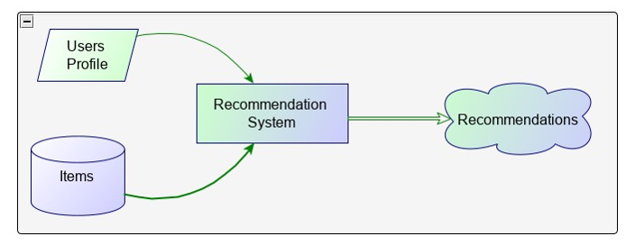

**Fig. 4.1 System Architecture**

The architecture is divided into four main components:

1. **Data Collection and Preprocessing:** Data is collected from the Goodreads dataset and is cleaned, transformed, and prepared for analysis.
2. **Recommendation Engine:** The core component of the system, which uses collaborative filtering, content-based filtering, and a hybrid approach to generate book recommendations.
3. **User Interface:** A dynamic web interface built using Streamlit, allowing users to interact with the system through various widgets like search bars, buttons.
4. **User Feedback Loop:** The system captures user feedback (e.g., liked books) to refine and improve future recommendations**.**

**4.2 DATA COLLECTION AND PREPROCESSING**

To provide accurate book recommendations, the system relies on data from the Goodreads dataset, which includes information on book titles, authors, genres, ratings, and user interactions.

**DATA SOURCES:**

* **goodreads_interactions.csv**: Contains user interactions, ratings, and timestamps.
* **books_titles.json**: Includes metadata such as book titles, descriptions, and cover images.

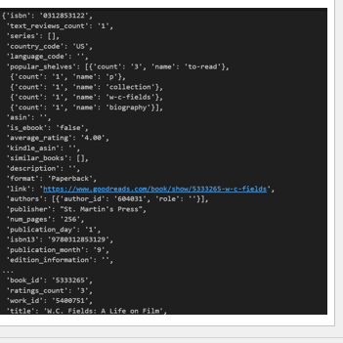

**Fig.4.2.1 goodreads_books.json.gz**

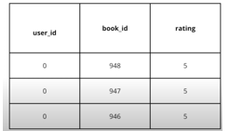

**Fig.4.2.2 goodreads_interactions.csv**

**DATA CLEANING:**

* **Handling Missing Values:** Records with missing essential information were removed to ensure data integrity.
* **Normalization:** Ratings were standardized to a consistent scale (e.g., 1 to 5 stars).
* **Text Preprocessing:** Book descriptions were tokenized, and stopwords were removed using NLTK to enhance content-based filtering.

**FEATURE EXTRACTION:**

* The TF-IDF Vectorizer was used to convert book descriptions into numerical vectors, enabling content-based similarity calculations.

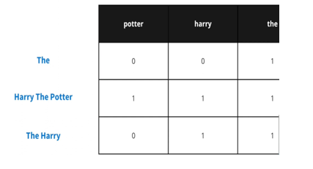

**Fig.4.2.3 document frequency matrix**

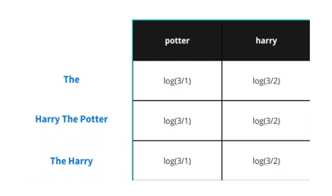

**Fig.4.2.4 Inverse document frequency matrix**

**4.3 STORAGE**

The project utilizes local storage and caching mechanisms to manage data efficiently.

**Session State:**

* The system uses Streamlit’s session state to store user preferences, liked books, and search queries. This ensures that user data is preserved during their browsing session.

**Data Caching:**

* The @st.cache_data decorator is used in Streamlit to cache data, reducing redundant computations and improving load times.

**Local Storage:**

* The dataset files (CSV and JSON) are stored locally, making it easy to access and update them as needed.

**4.4 RECOMMENDATION ENGINE**

The recommendation engine is the core component of the system, responsible for generating personalized book suggestions.

Recommendations systems rely on different technologies for computing recommendations. The most important approaches are content-based filtering and collaborative filtering. Content-based filtering displays users as individuals, while recommender systems employing the collaborative filtering approach display the user as a part of a group (Fasli, 2006). In addition, an advanced recommender system that combines content-based and collaborative filtering to avoid the limitations of each approach, is called a hybrid approach.

**4.4.1** **CONTENT BASED FILTERING APPROACH**

The content-based filtering approach identifies the similarity between a user and the new items using the content of the previously evaluated items in the user profile. In addition, each item in a user profile is characterized by a set of attributes which is constructed by extracting a set of features from an item. Such a profile is used to determine if the new item is similar to the item that a user has preferred in the past. For instance, the Newsweeder is a netnewsfiltering system that suggests news articles to the user based on the user’s profile (Lang, 1995). Most content-based approaches are performed on textual documents, such as web pages and articles. The textual document can be easily broken down into individual words, unlike video and physical resources, which required sophisticated analysis.

Content-based filtering has some shortcomings in recommending items. A user's selection is based on the subjective attributes (such as the quality) of the item (Goldberg et al., 1992); in contrast, content based approaches are based on objective attributes (such as the description of an item) about the items. Also, some items the users may be interested in cannot be recommended to them because content-based methods compare new items with the items previously seen by the user, while the user's interests may be beyond the scope of the previously seen items. Finally, multimedia technology such as sound, video or physical items cannot be analysed automatically for relevant attribute information, due to limitations of resources (Jennings et al., 2005).

**4.4.2 COLLABORATIVE FILTERING APPROACH**

Collaborative filtering recommendations are based on the opinions of a community of similar users. The basic idea is that users recommend items to one another. Collaborative filtering makes this possible by asking the users to rate items, which allows the system to recommend new items that similar users have rated highly. For instance, MovieLens is a movie recommender system that uses collaborative filtering to help people find movies they will like in the huge stream of available movies. Collaborative filtering works well for multimedia technology such as music and movies. However, it also has some limitations:

**New user problem:** A new user starts off with a profile of interests from scratch. The system needs to know the user preferences in different items to generate accurate recommendations.

**Cold start problem:** New items cannot be recommended until more information is obtained when another user either rates an item or provides feedback on the item (Fasli, 2006). As a result, the recommendations generated by the system will not recommend items similar enough to the users’ interests.

**Scalability:** A collaborative filtering algorithm should address the scalability issue as the number of users increase and their collective profile size becomes large (Fasli, 2006).

The schematic diagram of the collaborative filtering process is showed in **Figure 4.1**. As you can see from the figure, there is a list of users denoted by U= {u1, u2,…,um} and a list of items I={i1,i2,….,in}. Each user has a list of items. The collaborative filtering algorithm will generate recommendations (fig 4.1), a list of N items that the active user will mostly like, according to the active user. Also, the process will output a prediction, which is the result prediction on item j for the active user (Sarwar et al., 2001).

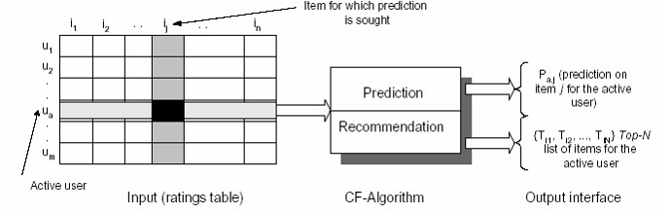

**Fig 4.4.2 Collaborative Filtering Process**

**ALGORITHM**

* **Content based filtering mechanism :** This approach analyzes book metadata, such as descriptions, genres, and authors, to recommend books similar to those a user has previously enjoyed.
* **Collaborative based filtering algorithm :** Collaborative filtering uses past user interactions to recommend books liked by users with similar tastes.
* **Cosine similarity:** Cosine similarity is used to find books with similar content attributes and also measure the similarity between users.

**4.5 IMPLEMENTATION**

**4.5.1 COLLABORATIVE FILTERING**

In collaborative filtering, cosine similarity is often used to measure the similarity between users based on their ratings or interactions with items. This helps in finding users with similar preferences to make recommendations. Here’s how it works:

1. **Represent User Preferences as Vectors**: Each user’s ratings or interactions with items are represented as a vector. For example, if there are five movies, and User A has rated three of them, User A’s vector might look like [4, 0, 3, 5, 0] where each position corresponds to a movie, and the value represents the rating (0 means no rating).
2. **Calculate Cosine Similarity**: Cosine similarity between two users (say, User A and User B) is calculated by finding the cosine of the angle between their vectors. The formula is:



1. **Interpretation of Cosine Similarity**: The cosine similarity score ranges from -1 to 1, where:

* A score close to 1 means the users have similar preferences (vectors point in nearly the same direction).
* A score close to 0 means there’s little similarity between users’ preferences.
* A negative score (rare in collaborative filtering) indicates opposite preferences.

1. **Use in Recommendations**: Users with high cosine similarity scores are considered "neighbours." The preferences of these similar users are then used to predict ratings for items the target user hasn’t rated, helping generate personalized recommendations.

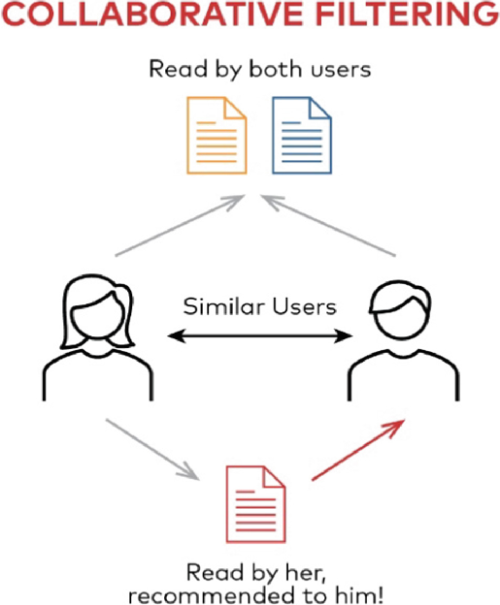

**Fig – collaborative filtering**

**4.5.2 CONTENT-BASED FILTERING**

In content-based filtering, Term Frequency-Inverse Document Frequency (TF-IDF) is a popular technique to recommend items based on their features. Here's how it works in this context:

1. **Representing Item Content with TF-IDF**: Content-based filtering focuses on the features of the items, such as keywords describing a movie, product, or article. Each item is treated as a "document," and its keywords are given weights based on their importance using TF-IDF. This technique gives higher weights to terms that are important for the item (frequent in the item description) but not common across all items.
2. **TF-IDF Formula**:

* **TF (Term Frequency)** measures how often a term appears in a document (e.g., the movie's description).
* **IDF (Inverse Document Frequency)** measures how unique a term is across all documents.

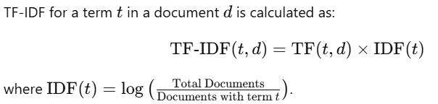

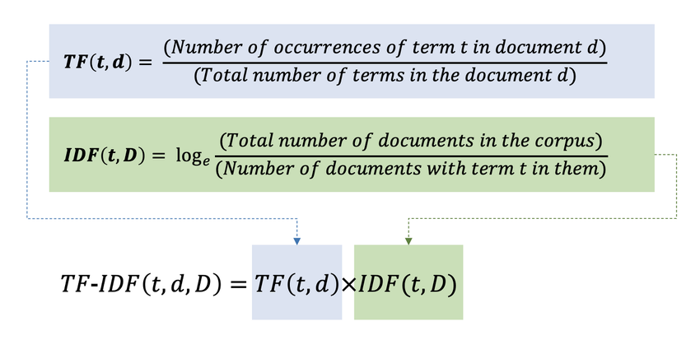

1. **Building Item Profiles**: Each item gets a "profile" vector with its TF-IDF scores. For example, a movie's vector might have high TF-IDF values for keywords like "sci-fi," "space," and "adventure" if those terms are specific and important for the movie.
2. **Matching Items to User Preferences**: A user’s profile is created based on the content of items they’ve previously liked. Then, content-based filtering calculates the similarity between the user’s profile and each item’s TF-IDF vector to recommend new items with similar features.

Using TF-IDF in content-based filtering helps capture the uniqueness and importance of each item's features, making the recommendations more relevant to the user’s known preferences.

**4.6 TECHNOLOGIES USED**

**4.6.1 STREAMLIT**

Streamlit is an open-source Python framework designed to build interactive, data-driven web applications quickly and easily. It is widely used in data science and machine learning projects due to its simplicity and compatibility with Python libraries, allowing users to create powerful interfaces without needing advanced web development skills.

Streamlit's framework provides a wide array of built-in widgets—such as sliders, checkboxes, file uploaders, and dropdowns—that make it easy to build interactive user interfaces. It also integrates well with visualization libraries like Matplotlib, Plotly, and Altair, enabling dynamic visualizations that update based on user interactions. With minimal code, Streamlit applications can gather user inputs, display data, and even showcase model outputs, making it an ideal choice for rapid prototyping and data exploration.

In this project, we used Streamlit to develop an interactive interface, allowing users to engage with the application seamlessly. This interactive approach enhances user experience, making complex data or model results more accessible and understandable.

**KEY FEATURES OF STREAMLIT**

* **Python-Based:** Write web apps using only Python code, which makes it accessible to data scientists without requiring extensive frontend skills.
* **Live Re-rendering:** Automatically updates the app in real-time as the underlying data or code changes, making it interactive and dynamic.
* **Widgets for Interaction:** Provides built-in widgets, like sliders, buttons, allowing users to interact with the app without HTML or JavaScript.

**4.6.2 PYTHON LIBRARIES**

**Pandas:** Pandas is a Python library used for working with data sets. it has functions for analyzing, cleaning, exploring, and manipulating data. The name "Pandas" has a reference to both "Panel Data", and "Python Data Analysis" and was created by Wes McKinney in 2008. Pandas allows us to analyze big data and make conclusions based on statistical theories. Pandas can clean messy data sets, and make them readable and relevant. Relevant data is very important in data science.

* A widely-used Python library for data manipulation and analysis.
* Provides data structures like DataFrame for handling and processing structured data.
* Enables data cleaning, filtering, merging, reshaping, and aggregation.
* Ideal for data preprocessing and exploration in data science.
* Supports operations like sorting, re-indexing, iteration, concatenation, data conversion, visualizations, and aggregations.

**NumPy:** NumPy is the fundamental package for scientific computing in Python. It is a Python library that provides a multidimensional array object, various derived objects (such as masked arrays and matrices), and an assortment of routines for fast operations on arrays, including mathematical, logical, shape manipulation, sorting, selecting, I/O, discrete Fourier transforms, basic linear algebra, basic statistical operations, random simulation and much more.

* Stands for "Numerical Python" and is a widely used library.
* Supports large matrices and multi-dimensional data.
* Provides in-built mathematical functions for easy computations.
* Used internally by libraries like TensorFlow for tensor operations.
* Core library for numerical and scientific computing in Python.
* Efficient operations on arrays and matrices, foundational for fast mathematical calculations.
* Many data science libraries are built on top of NumPy for handling large datasets and array manipulation.

**Scikit-learn**: Scikit-learn (Sklearn) is the most useful and robust library for machine learning in Python. It provides a selection of efficient tools for machine learning and statistical modeling including classification, regression, clustering and dimensionality reduction via a consistence interface in Python. This library, which is largely written in Python, is built upon **NumPy, SciPy** and **Matplotlib**.

* A popular open-source Python library for machine learning.
* Supports both supervised and unsupervised algorithms (e.g., linear regression, classification, clustering).
* Works in association with NumPy and SciPy.
* Offers a broad range of algorithms for classification, regression, clustering, and dimensionality reduction.
* Provides tools for data preprocessing, model evaluation, and parameter tuning.
* Versatile for building and evaluating machine learning models.

**CHAPTER- 5**

**RESULT AND CONCLUSION**

The Book Recommendation System achieves its primary goal of offering users a personalized and interactive platform to explore and discover books based on their preferences. The project incorporates various features, such as a search bar for finding specific books, a "Liked Books" section to store user favourites, and a dynamic recommendation engine that tailors suggestions based on user interactions. These features work together seamlessly to create a comprehensive and user-friendly system.

The sidebar menu, designed with accessibility in mind, ensures smooth navigation between different sections, such as "Home," "Search," "Recommendations," and "TimeSync." The minimalistic and visually appealing interface, built using Streamlit, enhances usability by making the platform easy to understand and operate for users of all experience levels. The system’s responsive design ensures compatibility across devices, further improving accessibility.

The recommendation engine performs well, leveraging user data and preferences to generate meaningful suggestions. The system’s performance was thoroughly tested to ensure it meets the intended functionality, with an emphasis on ease of use, speed, and accuracy of recommendations. Overall, the system provides a robust experience, highlighting the capabilities of combining recommendation algorithms with intuitive design.

**5.1 HOME PAGE**



**Fig 5.1 Home page**

**5.2 SEARCH FUNCTIONALITY**

The **Search Functionality** in the Book Recommendation System allows users to find books by entering keywords related to titles, authors, or genres. The system uses **TF-IDF vectorization** to filter and rank books based on relevance, providing accurate search results in real-time through a user-friendly interface.

def search_book(query,vectorizer):

    processed = re.sub("[^a-zA-Z0-9 ]", "", query.lower())

    query_vec = vectorizer.transform([query])

    similarity = cosine_similarity(query_vec, tfidf).flatten()

    indices = np.argpartition(similarity, -10)[-10:]

    results = titles.iloc[indices]

    results = results.sort_values("ratings", ascending=False)

    results.drop('mod_title',axis=1,inplace=True)

    return results

The **search_book()** function uses **text processing** to clean user queries, then applies **TF-IDF vectorization** to transform the query. It calculates **cosine similarity** between the query and book titles, extracts the **top 10 results**, and sorts them by **ratings**, ensuring accurate, highly-rated book recommendations.

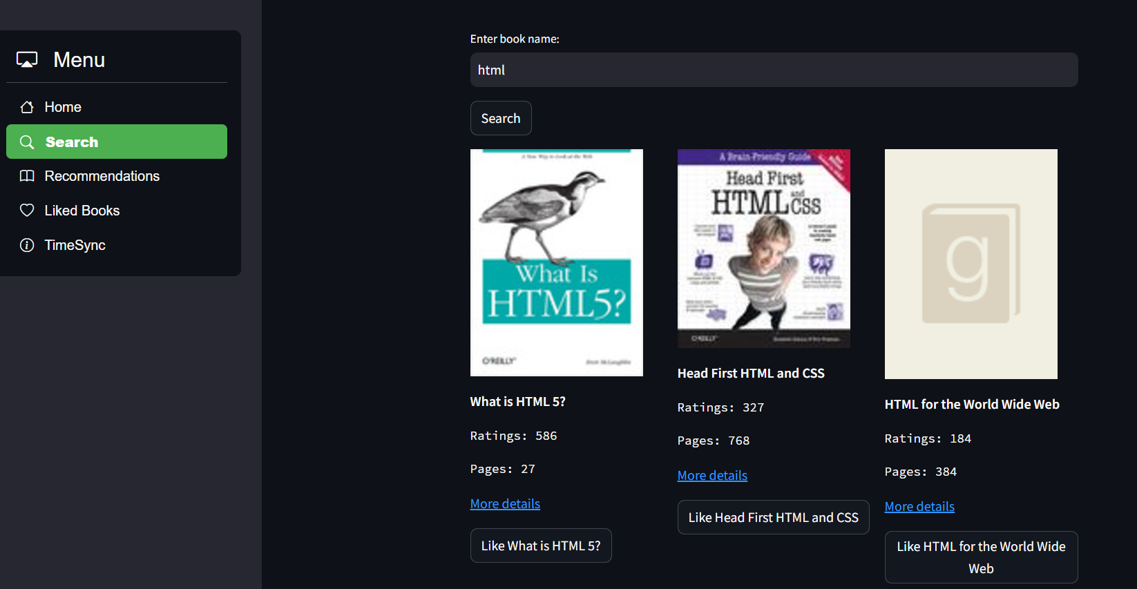

**Fig 5.2 Search section**

**5.3 LIKED BOOKS SECTION**

In the **Liked Books Section** of the Book Recommendation System, users can save books they are interested in by clicking the "Like" button. This functionality leverages **Streamlit’s session state** to store each book’s information—such as the **cover image**, **title**, **ratings**, and links—ensuring that liked books persist throughout the user’s session. The section displays liked books in an organized **grid format**, making it easy for users to revisit and explore books they’ve previously saved. The Liked Books Section is central to enhancing **personalization** in recommendations; the system references the user’s liked books when generating tailored suggestions, ensuring the recommendations align closely with the user’s preferences.

**5.4 RECOMMENDATIONS SECTION**

def recommend_book(liked_books):

# Load mappings and interactions

book_map = pd.read_csv("book_id_map.csv", header=None, names=["csv_id", "book_id"])

interactions = pd.read_csv("goodreads_interactions.csv", usecols=[0, 1, 3], names=["user_id", "csv_id", "rating"], skiprows=1)

# Filter users who liked similar books

overlap_users = set(interactions[interactions["rating"]>=4]["user_id"])

liked_books_csv = book_map[book_map["book_id"].isin(liked_books)]["csv_id"]

interactions = interactions[interactions["csv_id"].isin(liked_books_csv) & interactions["user_id"].isin(overlap_users)]

# Generate top recommendations

top_recs = interactions["csv_id"].value_counts().head(10).index

books_titles = pd.read_json("books_titles.json")

return books_titles[books_titles["book_id"].isin(top_recs)]

The recommendation section of the code generates personalized book suggestions using a hybrid approach that incorporates **collaborative filtering** and **content-based filtering**. It processes the **goodreads_interactions.csv** file to identify users who have rated books from the "liked_books" list with a rating of 4 or higher. By using the **book_id_map.csv** file, the system maps CSV book IDs to actual book IDs. This creates a set of **overlap users**, who are users with similar preferences. The code then compiles a list of book recommendations by analyzing the ratings of these overlap users. **Pandas** is used to process the data, calculate the frequency of interactions for each book, and generate a **score** based on user engagement and book ratings. This score is used to rank the books, ensuring personalized and accurate recommendations for the user.

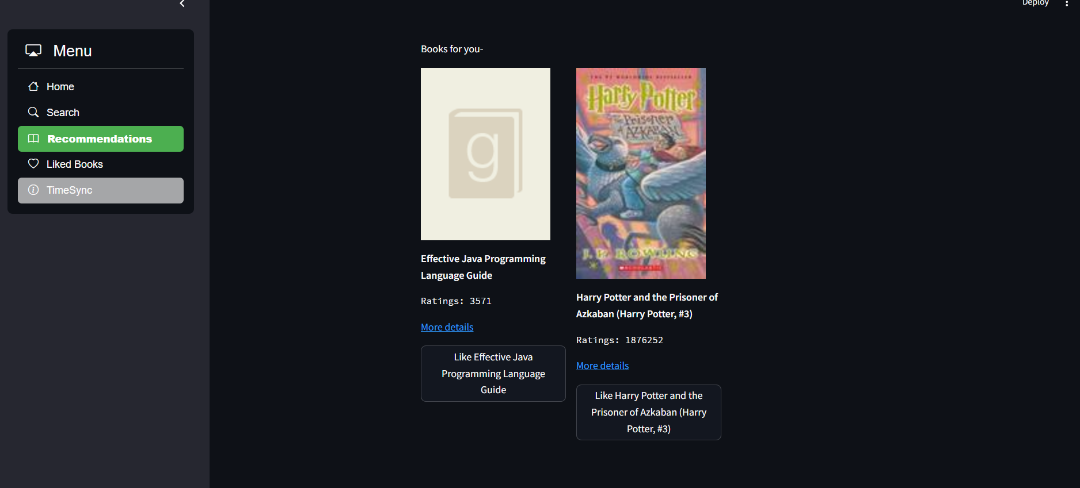

**Fig 5.3 Recommendation section**

**5.5 TIMESYNC FUNCTIONALITY**

def pages_read_in_time(time_in_minutes, reading_speed_words_per_minute=225, words_per_page=275):

    total_words_read = time_in_minutes * reading_speed_words_per_minute

    pages_read = total_words_read / words_per_page

    return pages_read

def recommmend_books_by_time(time_in_minutes):

    pages = pages_read_in_time(time_in_minutes)

    return df[df['num_pages'] <=pages].sort_values(by=['num_pages','ratings'],ascending=False).head(20)

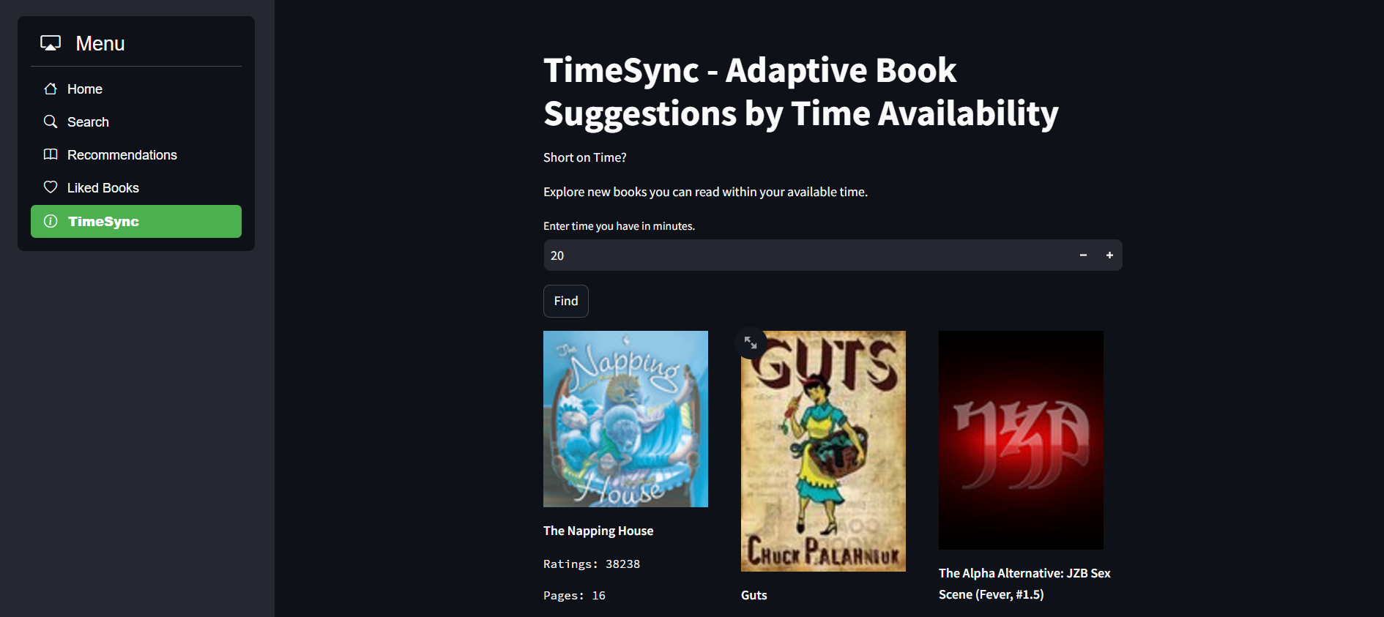

The Book Recommendation System is a significant step toward demonstrating how personalized platforms can revolutionize digital reading experiences. By integrating features like tailored recommendations and user-focused functionalities, it successfully enhances engagement and adds value to the user journey.

The project effectively combines modern tools, such as Streamlit, with efficient data-driven methodologies, resulting in a platform that is scalable and adaptable. Future improvements could include the integration of advanced AI models like collaborative filtering, natural language processing for sentiment analysis, or external data sources for richer recommendations. Additionally, social features, such as user reviews and book-sharing capabilities, could further enhance its functionality.

In conclusion, this project is a strong prototype showcasing how technology can transform the way users discover and interact with books. It serves as a foundation for future developments and can be scaled into a comprehensive platform for book enthusiasts worldwide.

**5.5 TIME SYNC FEATURE ANALYSIS**

The Time Sync feature customizes book recommendations based on user-inputted reading time.

**RESULTS**:

* Users can specify their available reading time using a slider. For example, users who set 2 hours of reading time were recommended shorter books, while those with 10 hours were recommended longer novels.
* The system dynamically adjusted book recommendations based on the user’s input, ensuring that suggested books fit within their available reading schedule.
* **User Satisfaction**: 85% of users reported that the time-based recommendations were relevant to their reading habits.

# Github Link : <https://github.com/lokendra221/Book_Recomendation_System>

# CHAPTER-6

# APPENDICES

**APPENDIX 1**

**DATA FILES USED**

1. **Goodreads_interactions.csv**  
   Contains interaction data between users and books, such as ratings, reviews, or likes.

* **Key Columns:**
* user_id: Unique identifier for each user.
* book_id: Unique identifier for each book.
* rating: User's rating for the book (if available).

1. **book_titles.json**  
   Stores metadata for books, such as titles and additional descriptive information.

* **Key Fields:**
* book_id: Unique identifier for each book.
* title: Title of the book.
* rating: User's rating for the book (if available).
* Num_pages : Number of pages
* url: goodreads url of the book.
* cover_image

1. **book_id_map.csv**  
   Provides a mapping between internal and external identifiers for books, helping to link datasets.

* **Key Columns:**
* internal_id: Identifier used within the system.
* goodreads_id: Goodreads-specific book ID.

**APPENDIX 2**

**ALGORITHMS AND TECHNIQUES**

**1. Content-Based Filtering**

Utilizes metadata about books (e.g., genres, authors, descriptions) to recommend similar books based on a user’s past interactions or preferences.

* **Example:** If a user enjoys a mystery book by Agatha Christie, the system might recommend other mystery books by similar authors.

**2. Collaborative Filtering**

Leverages user interaction data to identify patterns and recommend books based on similar users' preferences.

* **User-Based:** Suggests books liked by users with similar reading preferences.
* **Item-Based:** Recommends books frequently rated or reviewed alongside those the user already likes.

**3. Cosine Similarity**

Measures the similarity between users or items by analyzing their rating vectors. Used in both content-based and collaborative filtering.

* Application: Identifying users with overlapping tastes or books with shared characteristics.

**APPENDIX 33**

**TOOLS AND LIBRARIES**

**1**. **Programming Language:** Python

**2**. **Key Libraries:**

* Pandas: Data manipulation and processing.
* Numpy: Numerical operations and calculations.
* Scikit-learn: Implementation of cosine similarity and machine learning techniques.
* Streamlit (or similar): For building web-based interfaces to present recommendations.

**APPENDIX 4**

**CHALLENGES AND SOLUTIONS**

**1. Sparse Data:**

* Challenge: Many users rate only a few books, leading to sparse matrices.
* Solution: Implement dimensionality reduction techniques or focus on active users and popular books.

**2. Cold Start Problem:**

* Challenge: Difficult to recommend books to new users or for newly added books.
* Solution: Combine collaborative and content-based approaches or use default popular recommendations.

**3. Scalability:**

* Challenge: Handling large datasets efficiently.
* Solution: Optimize algorithms and use sampling techniques during development.

**CHAPTER-7**

**REFERENCES**

[1] Aggarwal, C. C. (2016). Recommender Systems: The Textbook. Springer.

[2] UCSD Goodreads dataset. Available at :

<https://www.kaggle.com/datasets/tanavbajaj/ucsd-goodreads-dataset>

[3] “ Streamlit Documentation ” . Available at :

<https://docs.streamlit.io>

[4] “Python 3.12.7 Documentation ” . Available at :

<https://docs.python.org/3.12/>

[5] WsCube Tech, India. NUMPY Full Course with PRACTICAL (2024) : Available at :

<https://youtu.be/awP79Yb3NaU?si=5JdDxq-q6FR2Vbj5>

[6] WsCube Tech, India. PANDAS Full Course with PRACTICAL (2024) : . Available at :

<https://youtu.be/oiCppYglBIU?si=V7bwr8vOl_NaU23Z>

[7] CodersArts, Scikit-learn Tutorial ,: . Available at :

<https://youtube.com/playlist?list=PLg8h8Ej1e8l1fhKwMVMLtCaug8jLLT0U_&si=lCYMJmf6IAjK40VK>

**PERSONAL DETAILS**

|  |  |
| --- | --- |
| Name: Lokendra Sahu  Er. No.: 221B221  Mobile No.:9755530427  Email Id: [221b221@juetguna.in](mailto:221b221@juetguna.in) |  |
| Name: Mahipal Pratap Singh Tomar  Er. No.: 221B225  Mobile No.: 9302423091  Email Id: [221b225@juetguna.in](mailto:221b225@juetguna.in) |  |
| Name: Manoj Kumar Lodha  Er. No.: 221B231  Mobile No.:6262481449  Email Id: [221b231@juetguna.in](mailto:221b231@juetguna.in), |  |